Permit Application Template
Example text to be used in locality-specific required permitting documents

2020 Network Project

Application for Permission to Undertake Scientific Studies at Name of the site

To

Dear Sir or Madam,

Dr. Name, Position at Institution/University, is collaborating on the MarineGEO Network Project “The good, the bad, & the ugly: carbon storage, eutrophication effects, and emergent health risks in the global marine sediment microbiome” awarded by The Marine Global Earth Observatory (MarineGEO) and the Smithsonian’s Tennenbaum Marine Observatories Network (TMON). This project requires fieldwork and sampling. Consequently, we would like you to consider this application for permission to undertake scientific studies at Name of the site and location. Please find included with this application a contact list of our working team.

Best Regards,

Signature

Dr. Name
(On behalf of Dr. Name)

Application for Permission to Undertake Scientific Studies at Name of the site

Personal Data

Name | Position | Contact  (Phone & email address)

Project Partnerships

Institution | Address
MarineGEO and Tennenbaum Marine Observatories Network  Smithsonian Institution | P.O. Box 37012  National Museum of Natural History, MRC 106  Washington, DC 20013-7012
The University of Hong Kong  Kadoorie Biological Sciences Building  Pokfulam Road, Hong Kong, PRC | School of Biological Sciences  The University of Hong Kong  Kadoorie Biological Sciences Building  Pokfulam Road, Hong Kong, PRC
The Swire Institute of Marine Science (SWIMS) | Swire Institute of Marine Science  Cape d’Aguilar Rd., Shek O, Hong Kong, PRC

Project Title

MarineGEO Network Project: The good, the bad, & the ugly: carbon storage, eutrophication effects, and emergent health risks in the global marine sediment microbiome.

Aims and Objectives

Understanding the effect of eutrophication on microbiome composition and resulting impacts on decomposition and carbon storage.

We aim to test the hypothesis that eutrophication
- increase the rate of decomposition and thus, reduce carbon storage

- the microbial biodiversity and decomposition rate vary as function of annual mean temperature (latitude)

Experimental design

PVC frames of 20 cm x 20 cm will be used to explore both hypotheses. Half of the frame will be filled by sand (control condition) or slow release fertilizer (eutrophication conditions). To understand the impact of eutrophication on decomposition rate, a simple tea bag assay will be conducted by adding tea bags of green and rooibos tea to the frame.

Field Site Proposed

Name of the site is suggested to be the designated site for this study. Description of the site. The site will be accessed during the pre-deployment survey to identify the depth and specific location of the sandy-mud bottom where the experiment will be realized.
In general, the PVC frames will be deployed to a sandy-mud bottom and shallow area (0.5-3m depth). Each frame will be buried in the first 15 centimeters of the sediment and secured with metal bars hammered in the sediment to stabilize them against current and waves. In total we propose to deploy 16 frames spaced 0.5 m apart, covering an area approximately 10m². The site will be accessed at day 1 for the deployment and at day 90 for the retrieval.

Figure 1. Map showing the location of the PVC frames at Site name

Duration

 | Year
 | Month | Month | Month | Month
Pre-deployment
Deployement
Retrival

Field Activities

Duration

The experiment will be conducted during the three warmest months of the year (sea surface temperature). The frames will be deployed on month year and will be retrieved after 90 days on month year.

Deployment

For both control and eutrophication conditions, 16 frames with four bags of green and rooibos tea will be deployed, each bag containing 2 grams of tea.
The green tea contains a high fraction of easily decomposable water-soluble compounds and consequently decompose faster. The rooibos tea contains a high fraction of compounds that are neither soluble nor hydrolysable and consequently decomposes more slowly. By using different types of tea with contrasting decomposability we can acquire the tea bag index (TBI) which consists of two parameters describing decomposition rate (k) and litter stabilization factor (S). This simple standardized method has been tested in different ecosystems such as mangroves and terrestrial forests. TBI will help to understand sediment’s potential carbon storage capacity based on extrapolation of decomposition data.
To explore the effect of nutrient pollution, half of the frames will be filled with 300g of slow release fertilizer (NPK-brand). Thirty holes covered by mesh will be drilled into the frames to ensure fertilizer diffusion. All the frames will be buried in the first 15cm of the sediment, containing the release of fertilizer. Control and eutrophication treatments will be spaced 5m apart to avoid any diffusion of the fertilizer to the control area.

Retrieval

After 90 days, sampling of seawater and sediment will be complete and frames will be removed. Rhizon samplers (n=6) will be used to collect 10ml of the seawater present in the first 10cm of the sediment. The seawater will be analyzed using flow injection analysis (FIA) to investigate the nutrients. Using 60ml syringe (n=12), ≈70g of sediment will be collect in the middle of the frames. The samples will be analyzed to:
- characterize the types, grain size and organic content of the sediment
- explore the meiofauna according to the different conditions
- characterize the microbial community using metagenomics shotgun sequencing according to the different conditions
The DNA of the sediment will be extracted and quantified before being sequenced. The taxonomic profile and community of the microbiome as well as their function will be investigated. Antibiotic gene resistance will be annotated to determine the correlation between anthropogenic stressors and human health risk factors. The composition and abundance of SRMs that have functional capabilities for major anaerobic cycling and sulfur metabolisms will be characterized. Data visualization will be realized in R.

Sedimentation rate

Three sedimentation traps will be deployed in the control and eutrophication areas to measure the quantity of sinking particulate organic and inorganic material.

Environmental Parameters

Two Hobo Pendant loggers (Figure 2) will be deployed at the two condition areas to continuously record the temperature every hour during the entire deployment period. Data will be retrieved after frame retrieval.

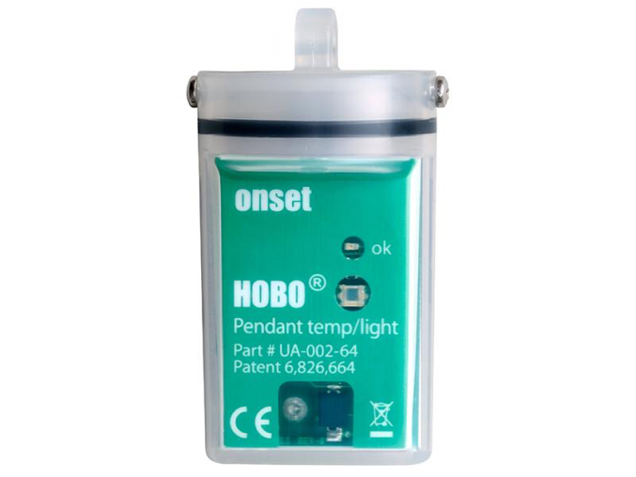

Figure 2. HOBO Pendant Temperature/Light Data Logger

To be added if you work in a controlled area: Justification for Activity to be Conducted Within a Controlled Area

The ocean regulates Earth’s climate. It is a sink for carbon dioxide (CO2), storing 50 times more carbon than the atmosphere. As such, we depend on the ocean to modulate climate and to facilitate the sequestration of greenhouse gases. Yet, coastal oceans and the services they provide are under threat from global climate change, eutrophication, overharvesting and habitat destruction (McKee et al., 2004; Worm et al., 2006) which affects the very organisms which drive those functions, particularly microbes. Indeed, anthropogenic activities are leading to environmental changes affecting marine biodiversity across a gamut of species including critical foundational groups such as corals, seagrass, and oysters (Knowlton & Jackson, 2008; Lamb et al., 2017; Phillips, 1977). Common to these ecosystems is a cryptic “microbial jungle” within marine sediments that has a critical role in biogeochemical cycling and underpins ecosystem productivity. Marine bacteria are particularly important in ocean sediments through the action of decomposition, carbon storage (DG Capone, DA Bronk, MR Mulholland, 2008) and as a reservoir of pollutants and pathogens (Guo et al., 2016).

As an ecosystem, marine sediments are ubiquitous and provide essential ecosystem services. Therefore, assess the microbial diversity in a controlled area and
understand the response of microbial communities to local disturbances is essential to properly assessing the functioning and stability of the coastal oceans (Griffiths & Philippot, 2013).

